Project Report

On

***"*** ***COVID-19 Situation in Bangladesh: A Comprehensive Analysis "***



**Instructed By**

Name: Dr.Tania Islam

Assistant Professor

Department of Computer Science and Engineering

University of Barishal

**Submitted By**

Name: Nazmul Hassan

Roll: 01-047-14

Batch – 47

Department of Bangla

University of Barishal

EDGE: BU-CSE Digital Skills Training

Computer Fundamentals & Office Application

### *1. Introduction*



COVID-19, a novel coronavirus disease, began spreading globally in late 2019 and rapidly became a pandemic. In Bangladesh, the first case was reported in March 2020, marking the beginning of a long battle against the virus. This project aims to analyze the situation in Bangladesh, focusing on the public health response, economic impact, social consequences, and the ongoing vaccination efforts. Understanding the pandemic's effects on Bangladesh is essential for better preparedness and future public health management.

Let me provide you with an overview of the COVID-19 situation in Bangladesh based on available information up to July 2024:



Bangladesh, like many countries, was significantly impacted by the COVID-19 pandemic. Here are some key points:

* Pandemic Impact
  + Bangladesh experienced multiple waves of COVID-19 infections
  + The country faced challenges with healthcare infrastructure and limited resources during peak pandemic periods
  + Urban areas, especially Dhaka, were particularly hard-hit
* Vaccination Efforts
  + The government implemented a national vaccination program
  + Initially relied on vaccines from various sources, including AstraZeneca and Chinese vaccines
  + Worked to expand vaccination coverage across different age groups and populations
* Economic Consequences
  + The pandemic severely affected Bangladesh's economy
  + Significant impacts on the garment industry, which is crucial to the country's exports
  + Many workers in informal sectors were economically vulnerable during lockdowns
* Healthcare Response
  + Expanded testing capabilities over time
  + Developed dedicated COVID-19 treatment facilities
  + Faced challenges with hospital capacity during peak infection periods
* Government Measures
  + Implemented various lockdown and social distancing measures
  + Provided economic support packages
  + Gradually relaxed restrictions as vaccination rates increased and infection rates stabilized

Please note that for the most current and precise information, I recommend consulting recent reports from the Bangladesh Ministry of Health or international health organizations like the WHO.

### *2. Overview of COVID-19 in Bangladesh*

The COVID-19 pandemic made its way into Bangladesh in March 2020, with the first confirmed case reported on March 8, 2020. The virus spread quickly, overwhelming the healthcare system and posing significant challenges to the economy and society. The government imposed nationwide lockdowns and restrictions to curb the virus's spread, but due to dense population clusters, limited healthcare resources, and informal labor markets, Bangladesh faced a severe challenge.

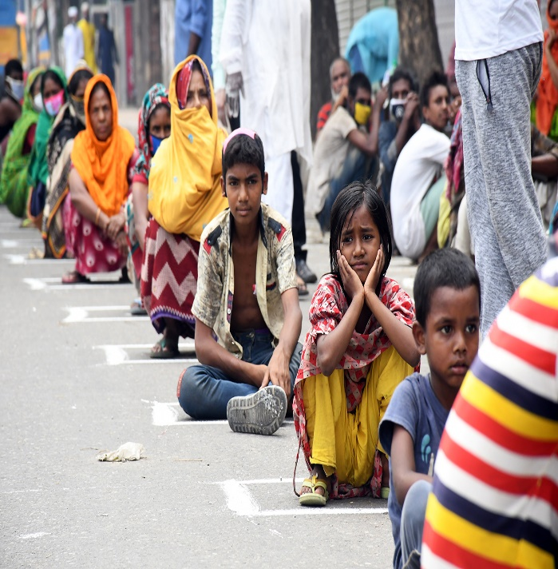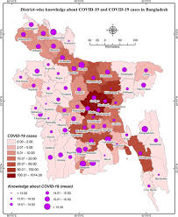

### *3. Timeline of COVID-19 in Bangladesh*

- *March 2020*: First confirmed case of COVID-19 in Bangladesh.

- *April 2020*: Nationwide lockdown announced to control the spread.

- *June 2020*: The number of daily cases peaks, especially in Dhaka.

- *August 2020*: Limited easing of restrictions to revive economic activities.

- *January 2021*: Bangladesh began its vaccination drive.

- *March 2021*: New waves of infections due to variants.

- *2023*: Gradual decrease in cases as vaccination coverage increases.

### *4. Government Response to COVID-19*

The Bangladesh government responded to COVID-19 with a series of health protocols, lockdowns, and social distancing measures. The government initially closed educational institutions, banned large gatherings, and imposed travel restrictions. Later, they rolled out economic relief packages to support vulnerable groups, including the poor, daily wage earners, and businesses.

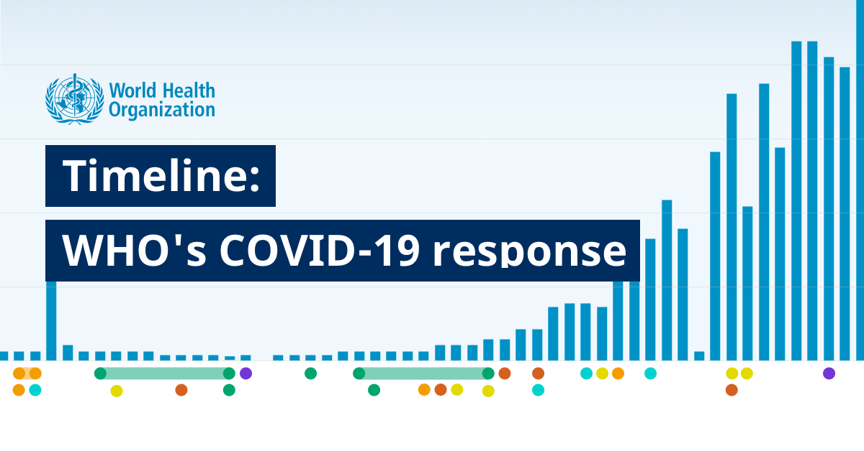

The Ministry of Health and Family Welfare, alongside the Directorate General of Health Services (DGHS), played a pivotal role in monitoring and managing the outbreak. The government also collaborated with international organizations like the World Health Organization (WHO) and UNICEF for guidance and support.

Key measures taken:

- Nationwide lockdowns and restrictions.

- Public health campaigns (mask-wearing, social distancing).

- Relief packages for the poor.

- Establishment of quarantine centers and COVID-19 treatment facilities.

### *5. Public Health Impact*

The public health impact of COVID-19 in Bangladesh has been significant. Healthcare facilities were overwhelmed, with many hospitals reporting a shortage of ICU beds and ventilators. The virus disproportionately affected people with underlying health conditions such as diabetes and hypertension.

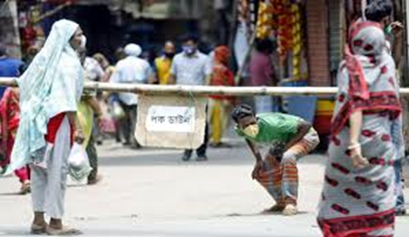

Challenges:

- Shortage of medical supplies and personal protective equipment (PPE).

- Limited testing capacity initially, leading to underreporting of cases.

- A shortage of healthcare workers and inadequate infrastructure in rural areas.

Despite these challenges, Bangladesh has taken steps to improve its healthcare response by increasing testing capacity, setting up dedicated COVID-19 hospitals, and ramping up medical supplies.

### *6. Economic Impact*

COVID-19 has caused severe economic disruptions in Bangladesh, impacting industries like textiles, agriculture, and tourism. The government initially focused on public health measures but later introduced economic relief programs to mitigate the economic fallout.

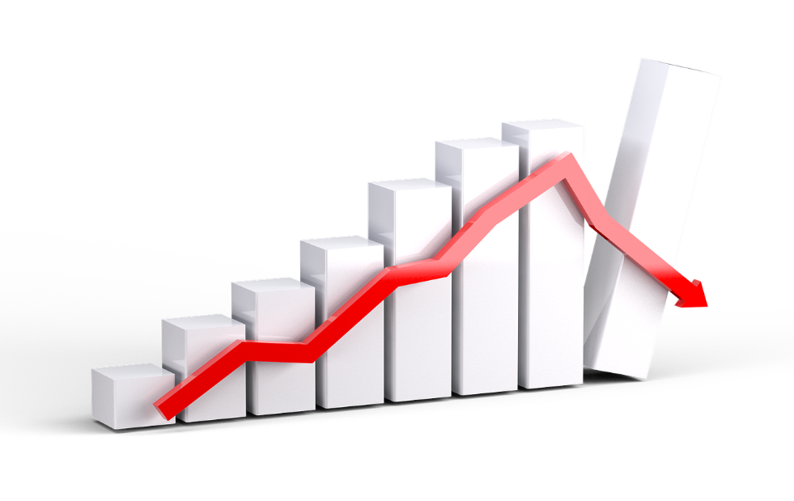

- *Impact on the Textile Industry*: The country's textile sector, a major exporter, faced severe setbacks due to global demand decline. Many factories had to suspend operations, leading to the loss of millions of jobs.

- *Agriculture*: Farmers experienced disruptions in supply chains, especially during harvesting seasons. Transport restrictions also affected food distribution.

- *Informal Sector*: The informal labor sector, which employs a significant portion of the population, was hit hardest due to the lockdowns and restrictions on movement.

Government Initiatives:

- Cash assistance for low-income groups.

- Loan facilities for small and medium enterprises.

- Economic stimulus packages to keep industries afloat.

### *7. Education and Social Impact*

The education system in Bangladesh was severely affected by the pandemic. Schools, colleges, and universities were closed for extended periods, shifting to online learning.

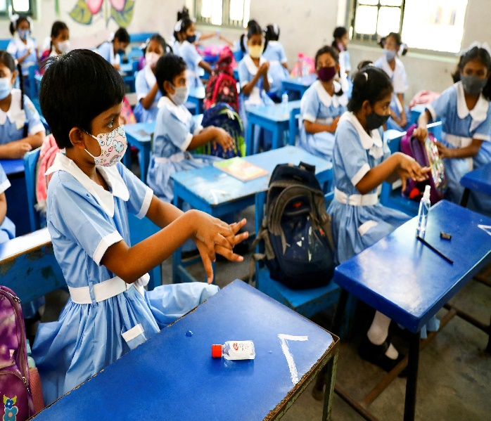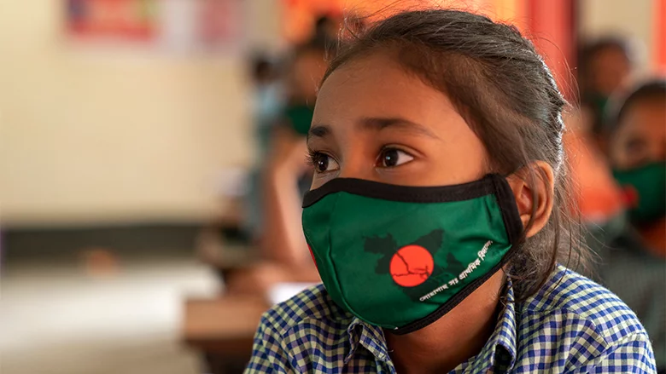

However, challenges such as a lack of internet access and digital devices in rural areas prevented equitable access to education.

Socially, the pandemic led to:

- *Mental Health Issues*: An increase in anxiety, depression, and stress due to uncertainty, economic instability, and isolation.

- *Poverty*: Rising poverty levels as many families lost their livelihoods during lockdowns.

- *Gender Inequality*: Women faced additional challenges, especially in rural areas, including increased domestic violence and loss of income.

### *8. Vaccination Campaign in Bangladesh*

Bangladesh launched its vaccination campaign in January 2021, initially focusing on healthcare workers and the elderly. The country received vaccine supplies through global initiatives like COVAX and bilateral agreements. As of 2023, a significant portion of the population has been vaccinated, but challenges such as vaccine hesitancy and distribution issues remain.

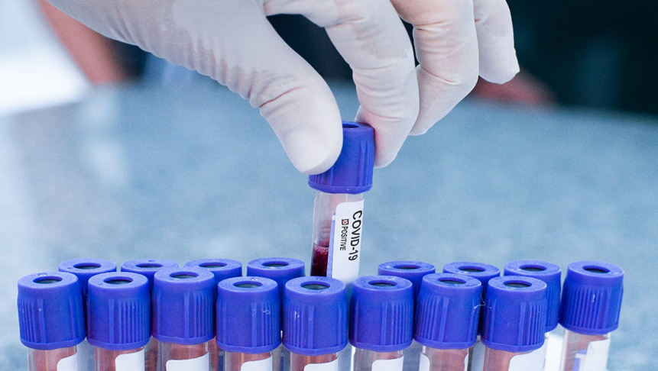

Key facts:

- Bangladesh started its vaccination program with the Oxford-AstraZeneca vaccine.

- The government has targeted vaccinating [percentage]% of the population.

- Vaccination centers have been established across the country.

### *9. Challenges Faced During the Pandemic*

Bangladesh faced several challenges in managing the COVID-19 pandemic, including:

- *Healthcare System Strain*: The healthcare infrastructure was not equipped to handle the surge in cases.

- *Economic Hardships*: The informal economy, which constitutes a large part of Bangladesh's workforce, suffered greatly.

- *Social Inequalities*: The poor and marginalized groups were disproportionately affected by both the virus and the economic consequences.

- *Public Awareness*: Initial lack of public awareness about the virus and preventive measures slowed the response.

### *10. Conclusion*

The COVID-19 pandemic has been a major test for Bangladesh, challenging the healthcare system, economy, and society as a whole. Despite the significant setbacks, the country has shown resilience in its fight against the pandemic. The lessons learned from this experience, particularly in terms of healthcare infrastructure, economic resilience, and public awareness, will be crucial for future preparedness in the event of another crisis.

### *11. References*

- Bangladesh Ministry of Health and Family Welfare. (2020). COVID-19 Updates.

- World Health Organization. (2021). Global COVID-19 Response.

- The Daily Star. (2020). COVID-19 Impact in Bangladesh.

- UNICEF. (2021). Education during the Pandemic in Bangladesh!